**Forresta Café: Modern Green Elegance with Earthy Sophistication**

**T-CPET31GLA**

**Web Design and Development Lab  
  
Submitted by:  
Asano, Mirai F.**

**Submitted to:  
Engineer Ron Anthony Delos Santos**

**Date Submitted:  
12/19/2025**

**De La Salle University - Dasmariñas College of Engineering, Architecture, and Technology Computer Engineering Department**

**INTRODUCTION**

In today’s digital age, cafés can greatly improve their service by using online systems that simplify and speed up the ordering process. This project introduces the **Forresto Web-Based Café Ordering System**, a platform designed with a **Green and Brown Modern** aesthetic to reflect our botanical, forest-to-table identity.

The system allows the admin to make a menu, easily categorize products, and submit them online through an organic interface. By providing a user-friendly experience that reduces errors and improves management, this project applies essential web development skills to offer a practical solution that enhances convenience for both cashiers and managers, and supports smoother cafe operations.

**3. SYSTEM SPECIFICATION**

Role-based authentication – The system checks the user’s role and redirects.  
Admin role – Access to menu browsing (same with cashier) and cart functionality plus exclusive access to products management and report generation.

**3.1 Image Handling**

Product imagery is managed through a streamlined admin upload process. By storing relative file paths in the IMAGEPATH field, the application can dynamically inject images into the frontend menu, allowing for real-time inventory updates without manual code changes.

**3.2 Technology Stack**

- MSSQL for Database  
- HTML, CSS, JavaScript for Frontend  
- Bootstrap Libraries for styling, Google Fonts  
- XAMPP with SQLSRV driver server environment

**3.3 Menu Display**  
The menu displays product data retrieved from the database. Products are displayed with  
- Product Image  
- Product Name  
- Description  
- Category  
- Price  
These details can later on be edited by an administrator.

**3.4 Cart Functionality**  
The cart is session-based and allows order modification (delete or increase/decrease of qty).  
There’s also a discount functionality, allowing senior discounts to be applied.

**3.5 Order Management System**Centralized Order Management

* Real-time Tracking: View all active orders, complete with customer profiles and specific fulfillment instructions.
* Detailed Breakdowns: Access itemized lists of products, quantities, and pricing for precise order assembly.
* Status Control: Streamlined workflow to mark orders as "Completed" once fulfilled.
* Historical Logs: Maintain a searchable record of past transactions with accurate timestamps for better operational oversight.

**3.6 Account Management System**User & Staff Oversight

* User Directory: Access a comprehensive list of all registered customers and staff members.
* Profile Management: Modify user metadata, including usernames and account designations.
* Permission Logic: Dynamically manage staff roles to ensure users only access the features relevant to their position.
* System Security: Enforce role-based restrictions to safeguard administrative tools and data.

**3.7 Menu Item Cards**Product Interface & Customization The menu is presented through a series of sleek, minimalist product cards designed to highlight the café's offerings without visual clutter. Each card features:

* Refined Imagery: High-resolution product photos that utilize subtle transitions to maintain a clean, high-end feel.
* Contemporary Card Layout: A modern design focused on clarity, utilizing generous white space and sharp typography to ensure readability.
* Essential Product Details: Concise descriptions that focus on the premium quality and ingredients of the Forresto menu.
* Instant Cart Integration: A streamlined "Add to Cart" feature powered by AJAX for a fast, refresh-free user experience.
* Fluid Responsiveness: A fully adaptive layout that preserves the minimalist aesthetic across mobile, tablet, and desktop screens.

**4. UI/UX DOCUMENTATION**

**Design Philosophy & User Interface**

The **Forresto** website adopts a minimalist, high-end aesthetic that emphasizes clarity and modern sophistication. By utilizing strategic white space and a clean layout, the interface directs the user’s focus toward the cafe’s premium offerings without visual clutter. Interactive elements, such as buttons that transition to deeper shades on hover, provide subtle yet effective feedback. The design prioritizes a "less is more" approach, combining a contemporary professional look with intuitive navigation, ensuring the brand feels both current and accessible.

**Features & Functionality**

Efficiency is at the core of the user experience. Customers can navigate the menu through streamlined category tabs and customize their orders with precise quantity controls. The integration of **AJAX** allows users to add items to their cart instantly, maintaining a fast and fluid browsing experience. For internal operations, the system features a secure management suite. Administrative workflows for products, orders, and user accounts are strictly separated by privilege levels, ensuring that staff can manage the business effectively while preventing unauthorized or accidental changes.

**Technical Architecture**

Developed using the **XAMPP** stack, the platform utilizes **PHP** for server-side processing and **MSSQL** as the database backend to ensure reliable data persistence. The frontend is built on **Bootstrap**, providing a responsive grid system that maintains the site's modern look across all screen sizes. Custom **CSS** is applied to refine the minimalist branding and typography. By isolating specific actions into individual pages, the architecture ensures high maintainability and a clear, logical flow for the user. The result is a high-performance web application that balances modern usability with a polished, brand-aligned visual identity.

**4.1 Wireframes**

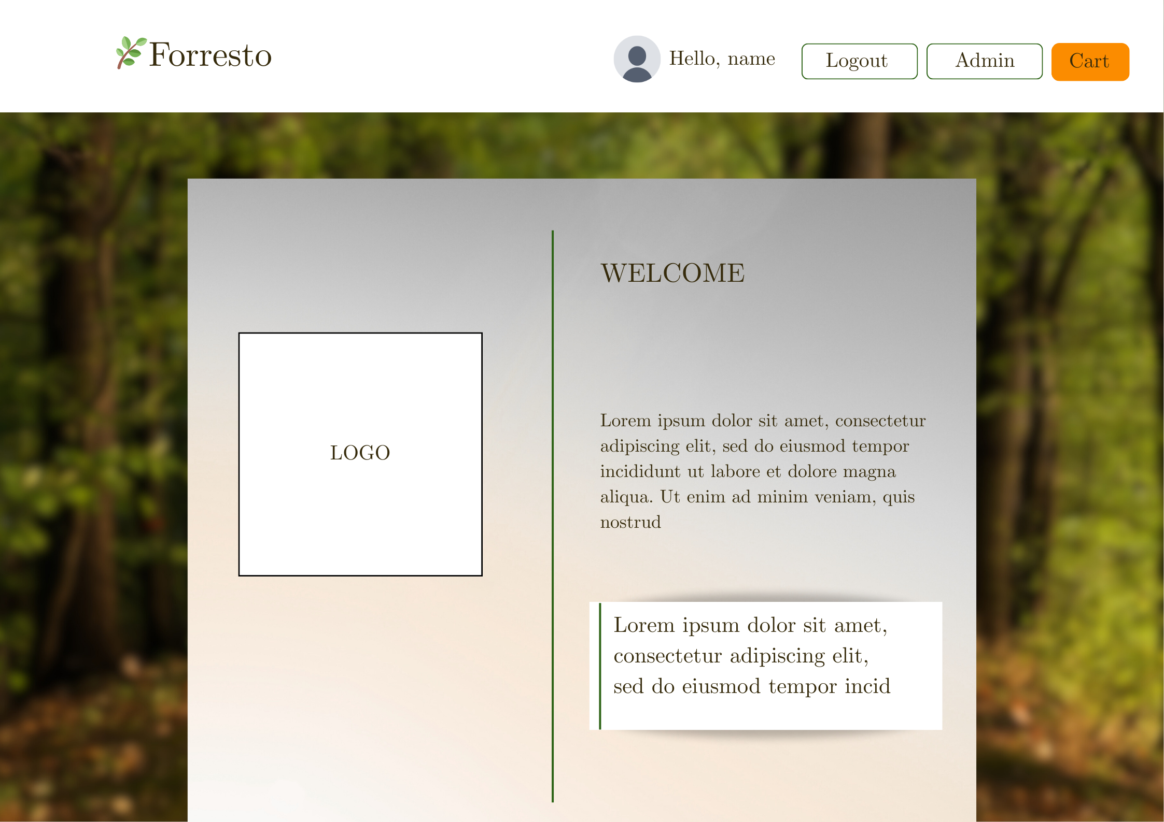

**4.2 Final Design**

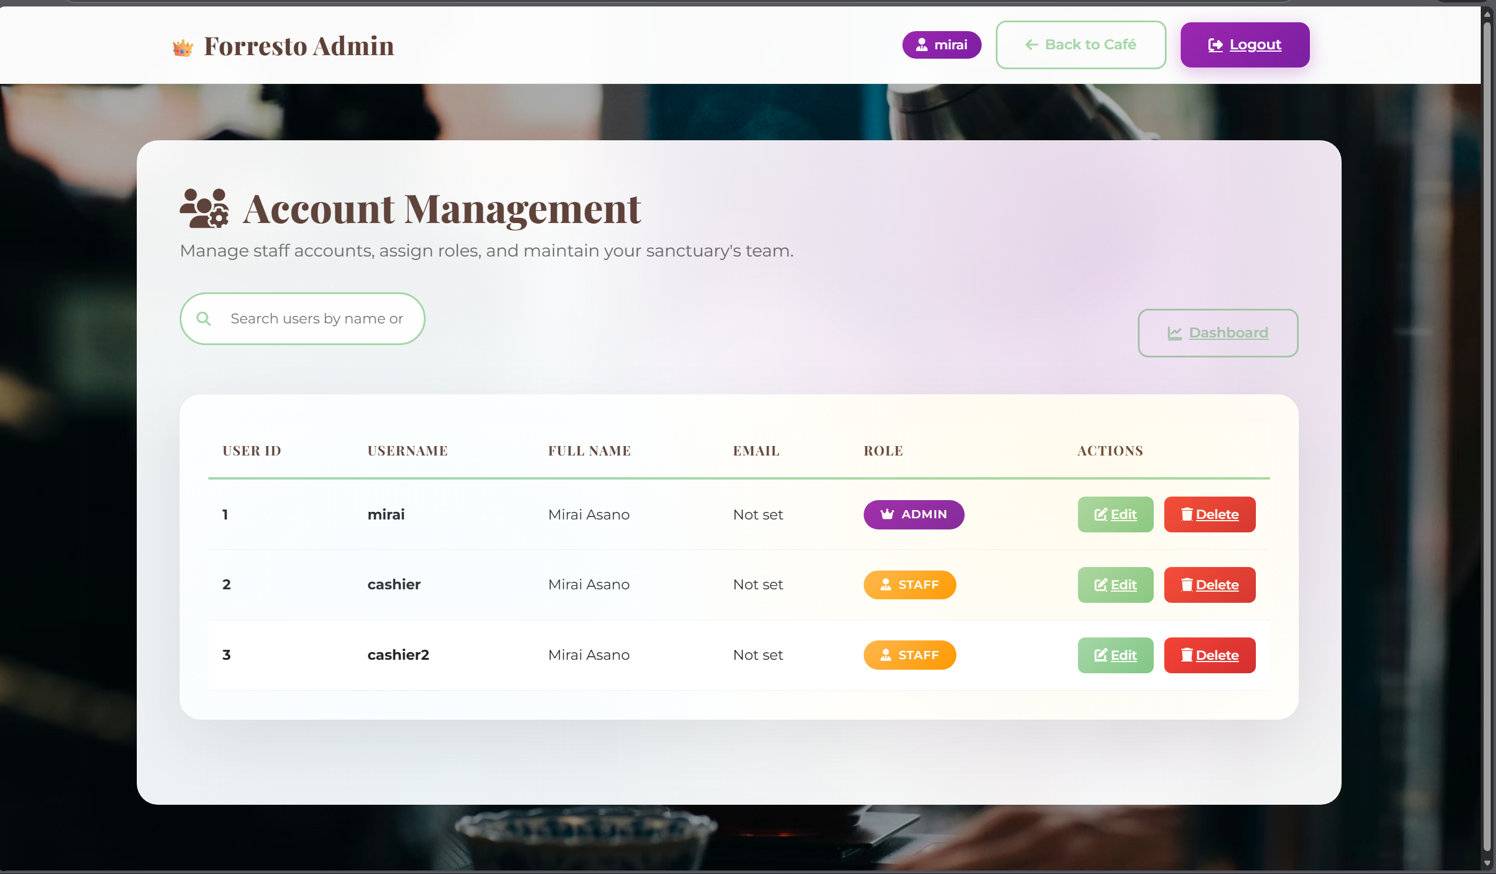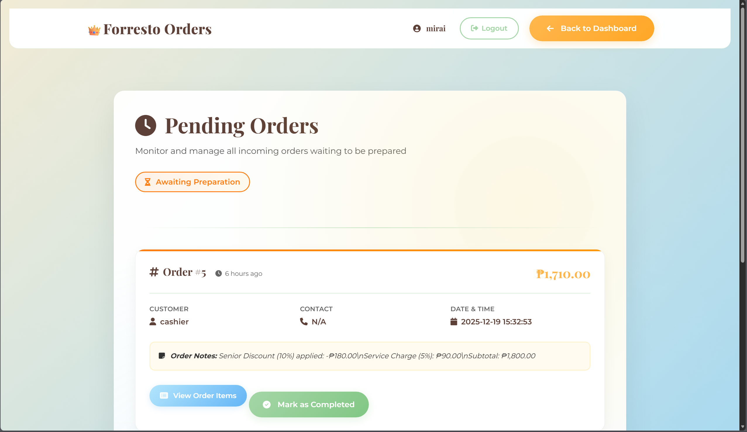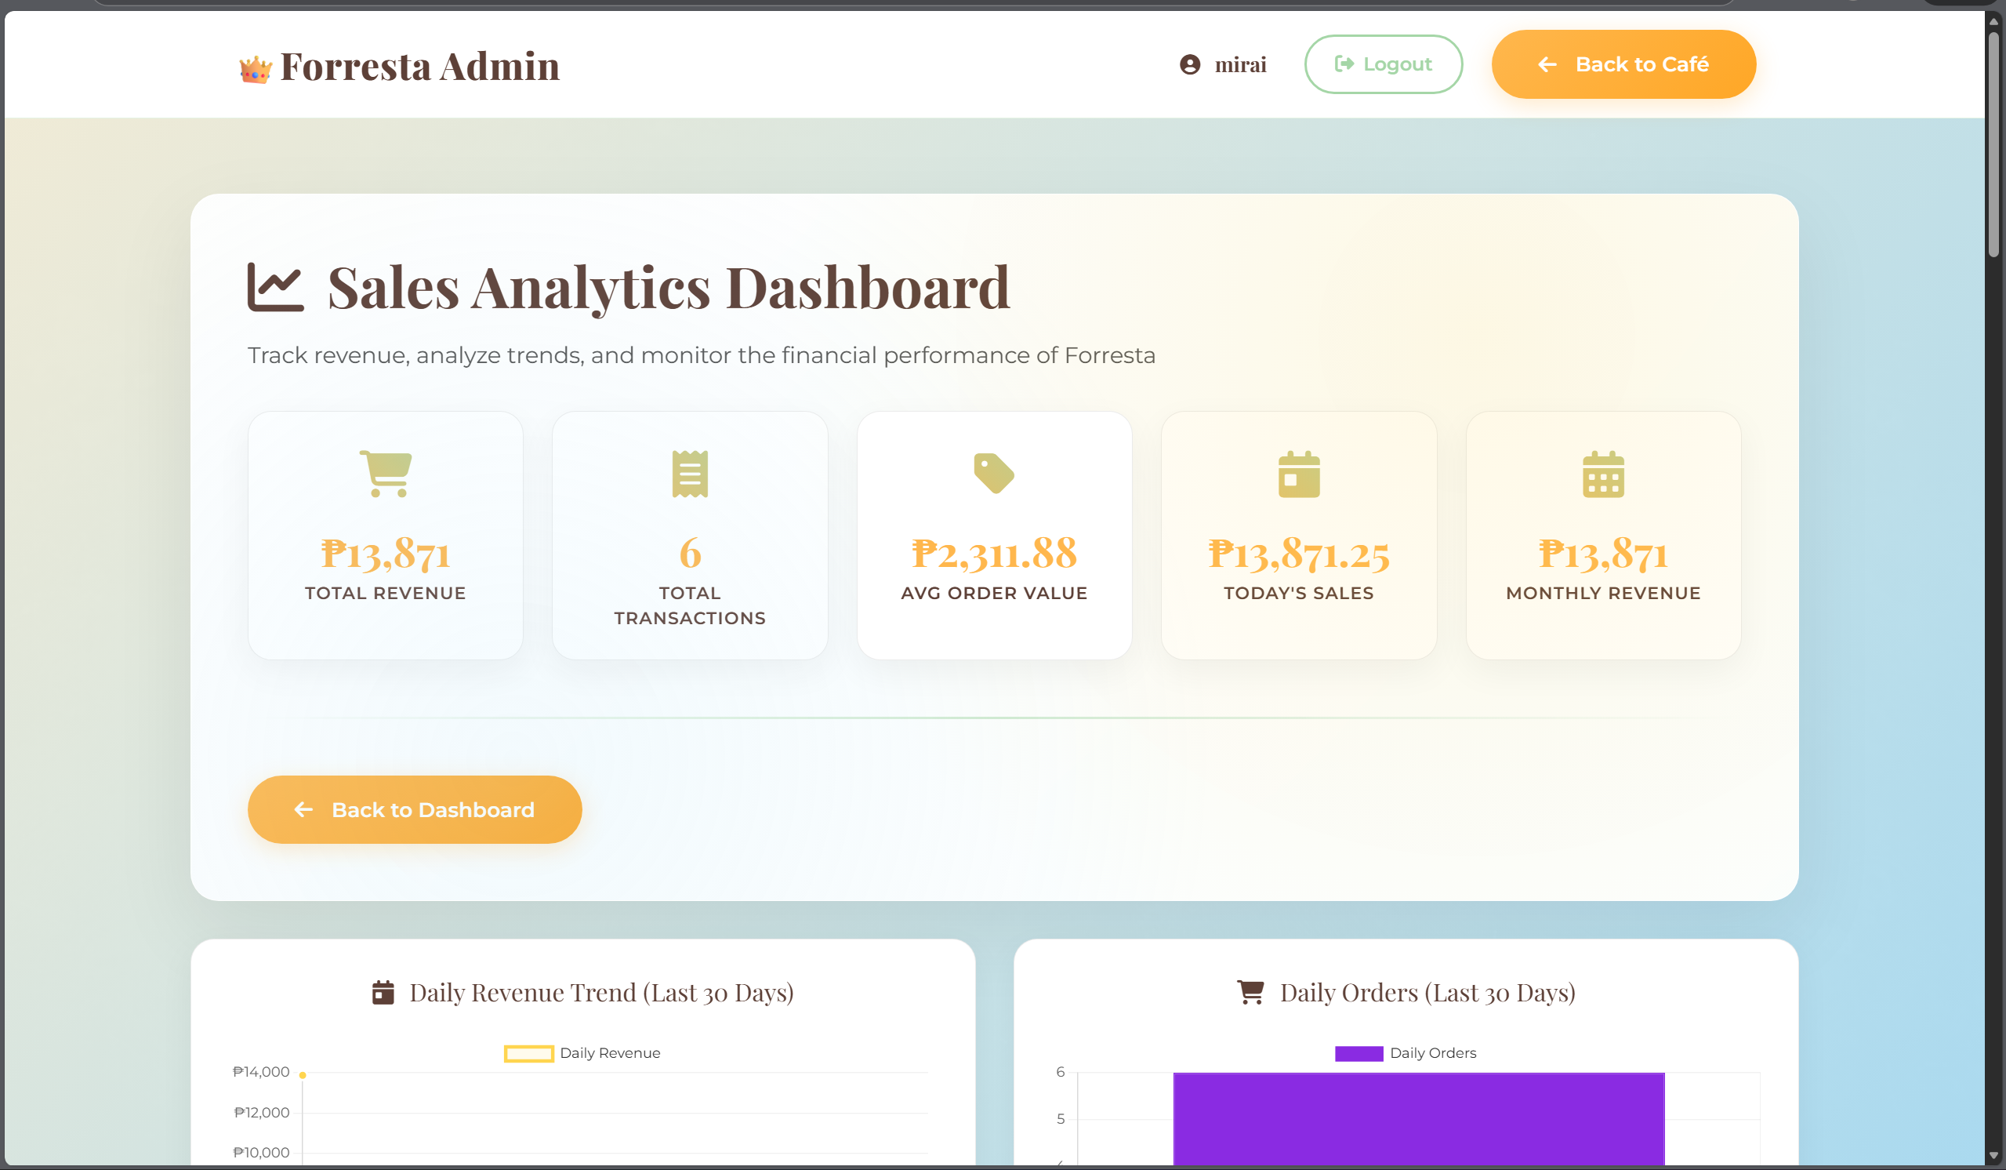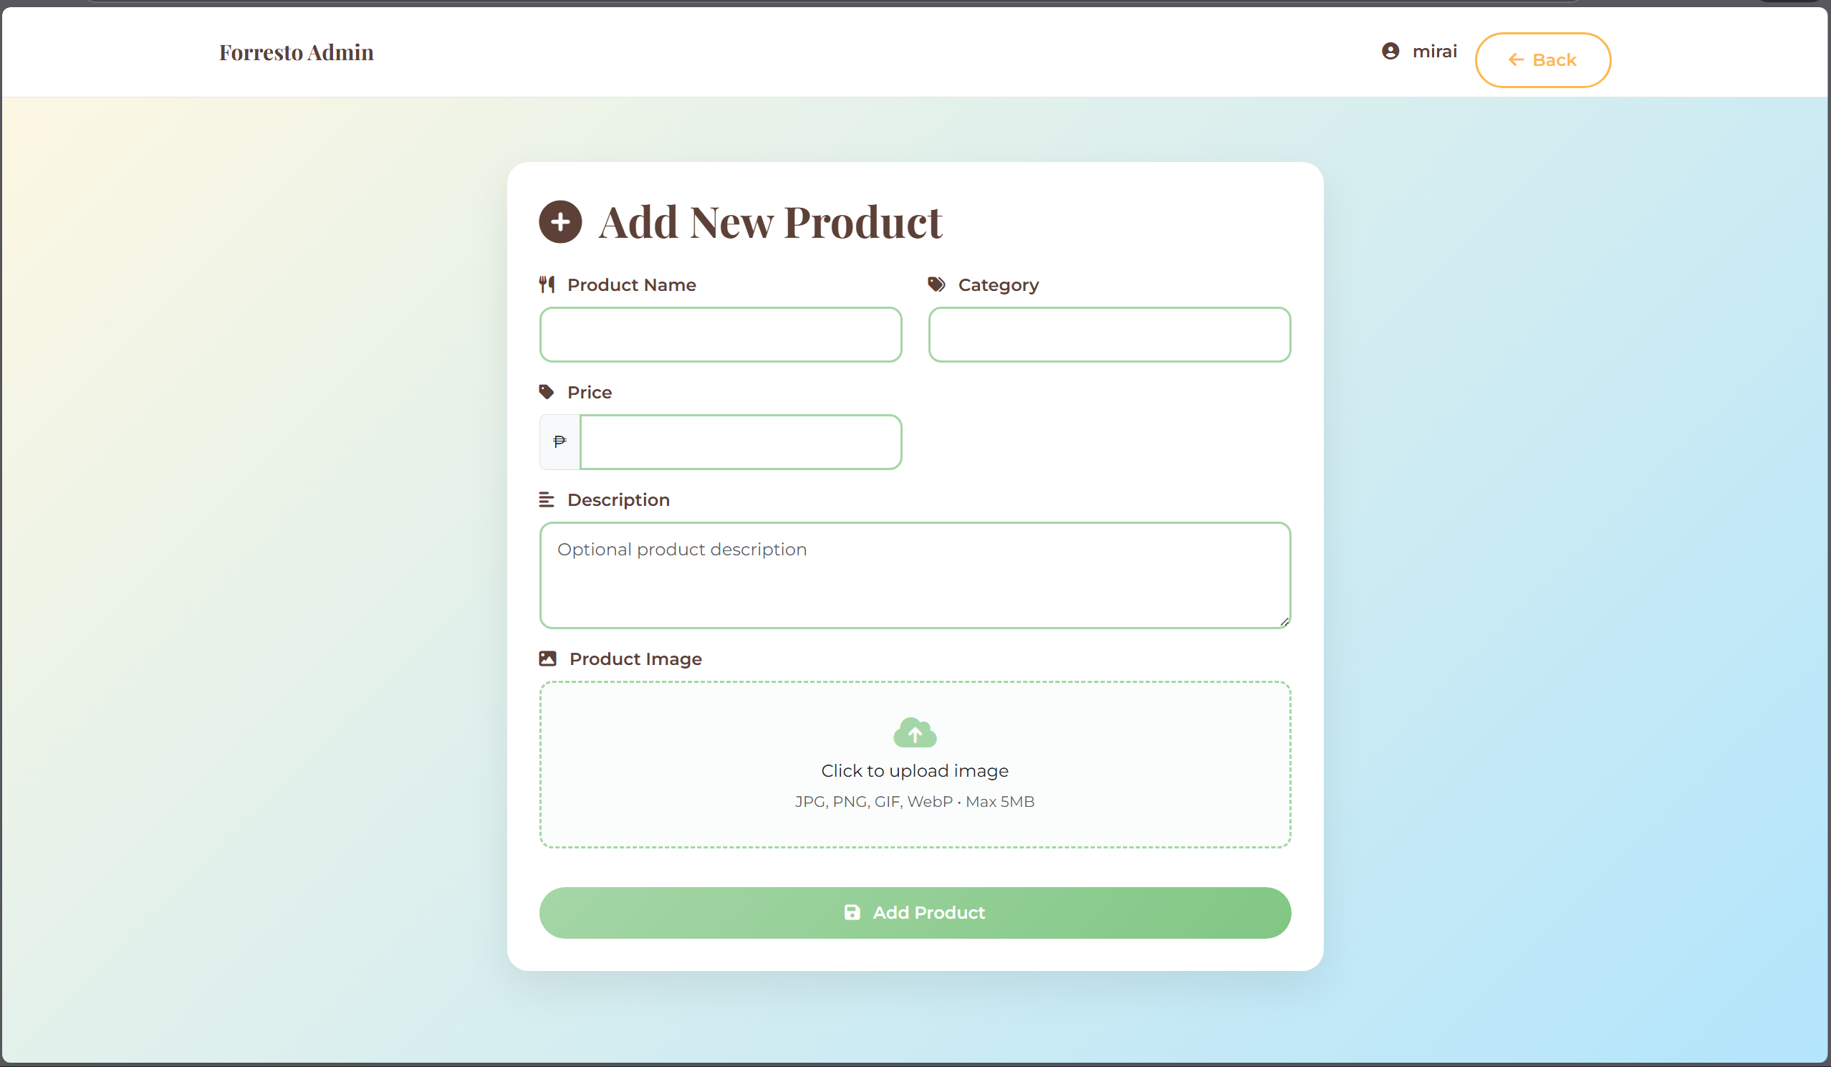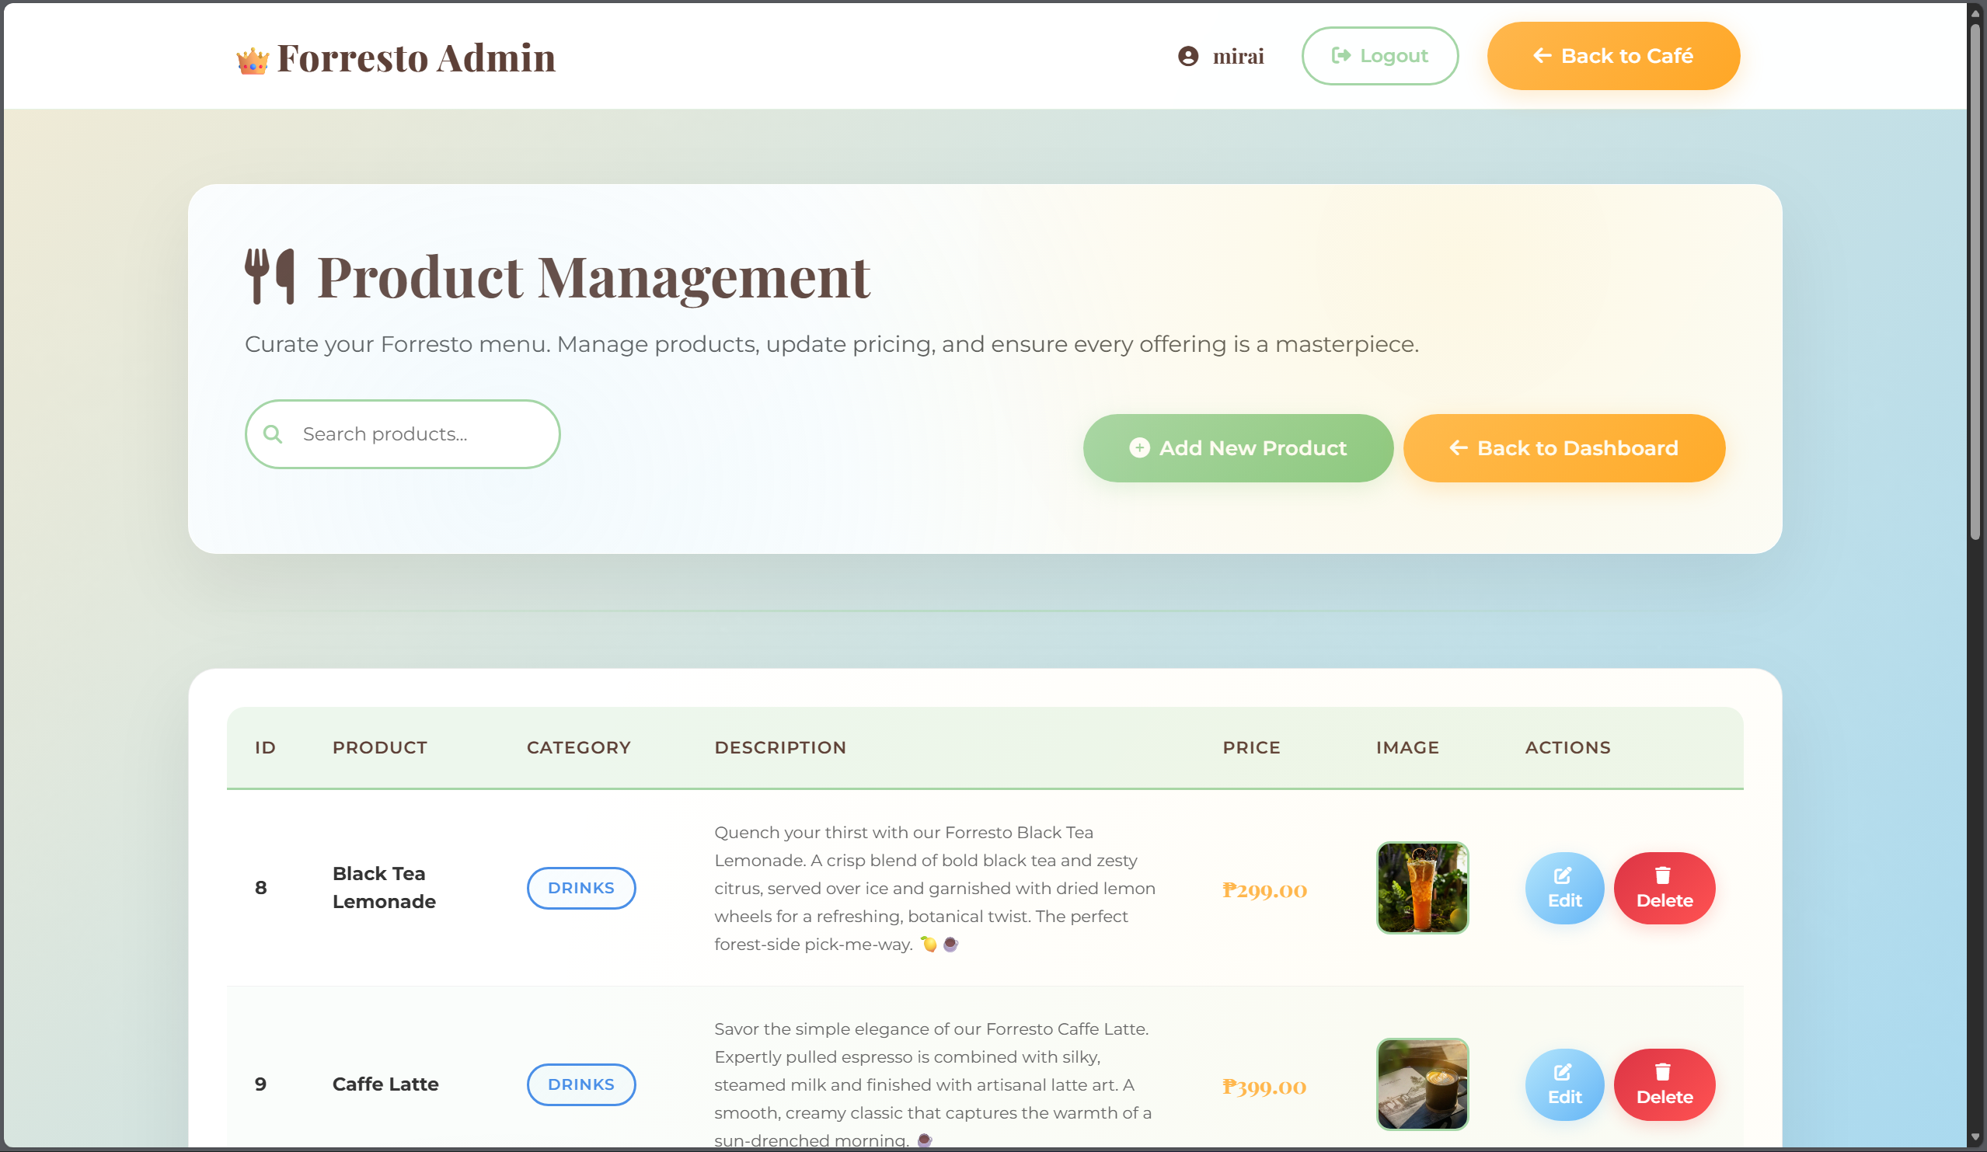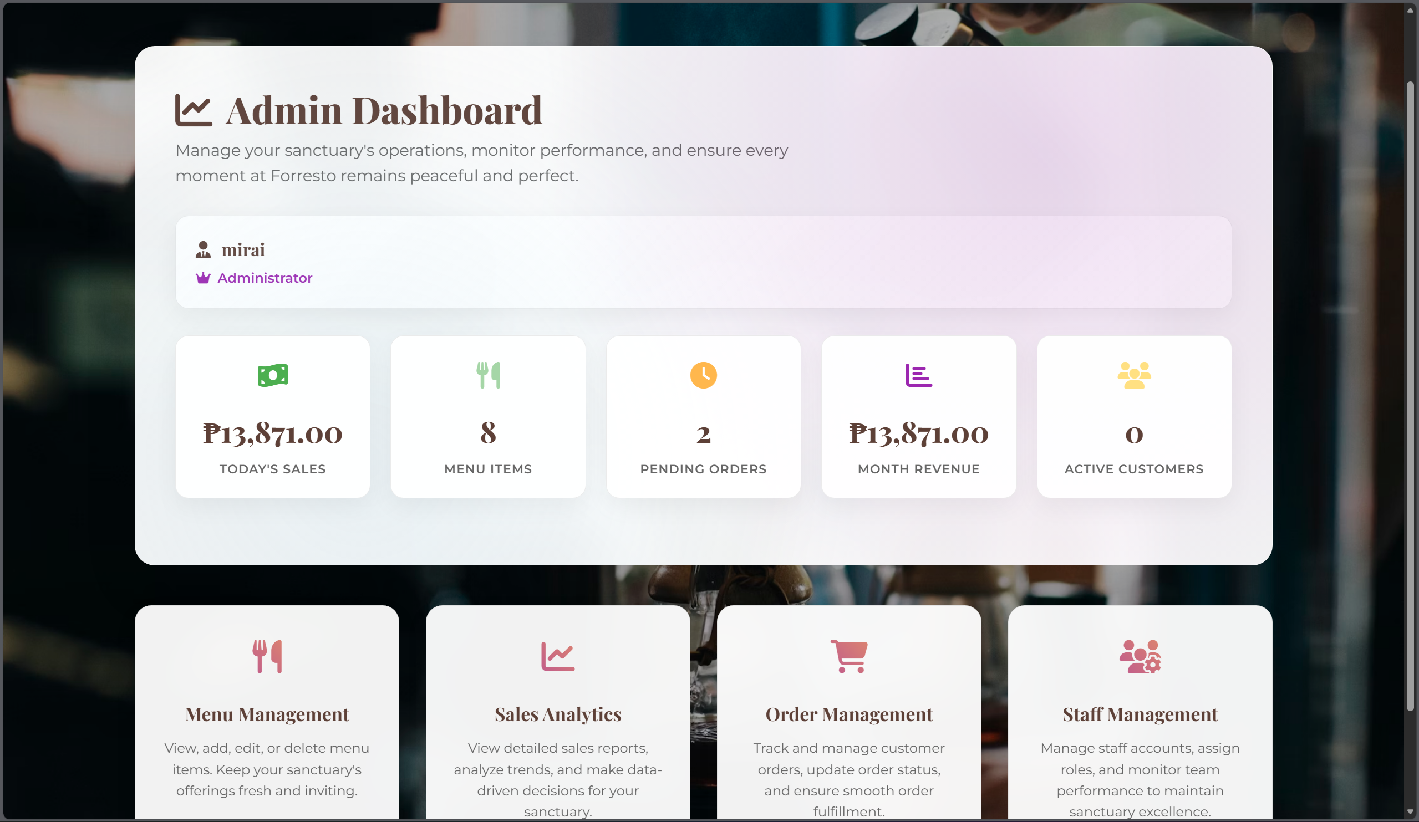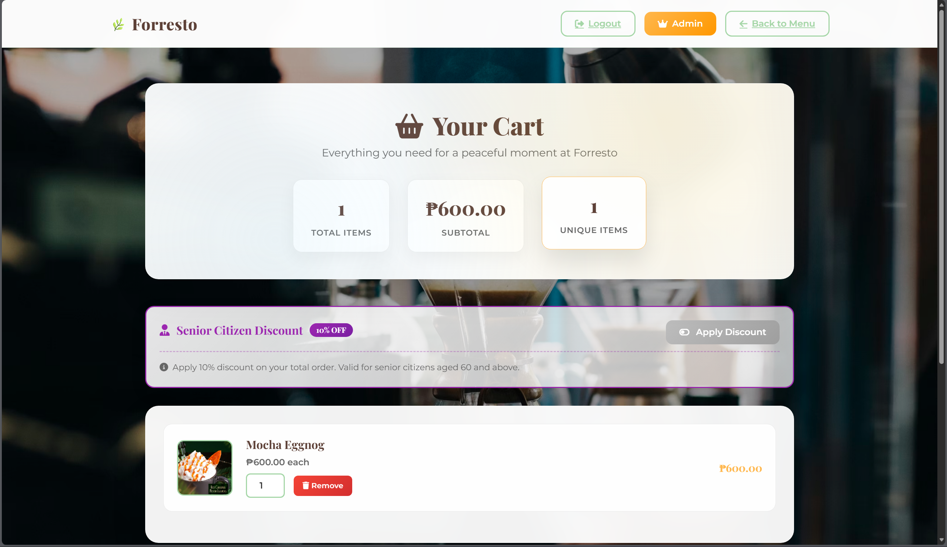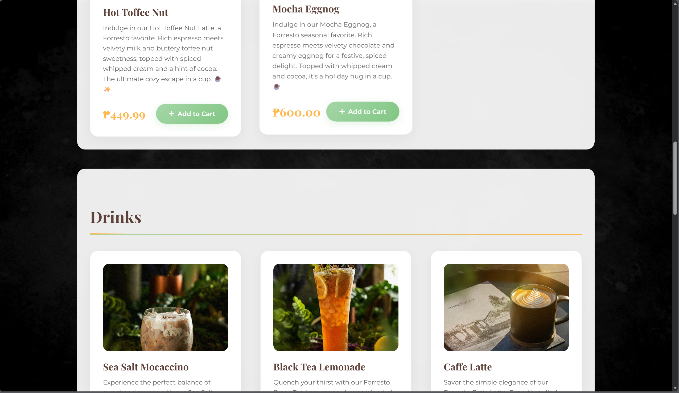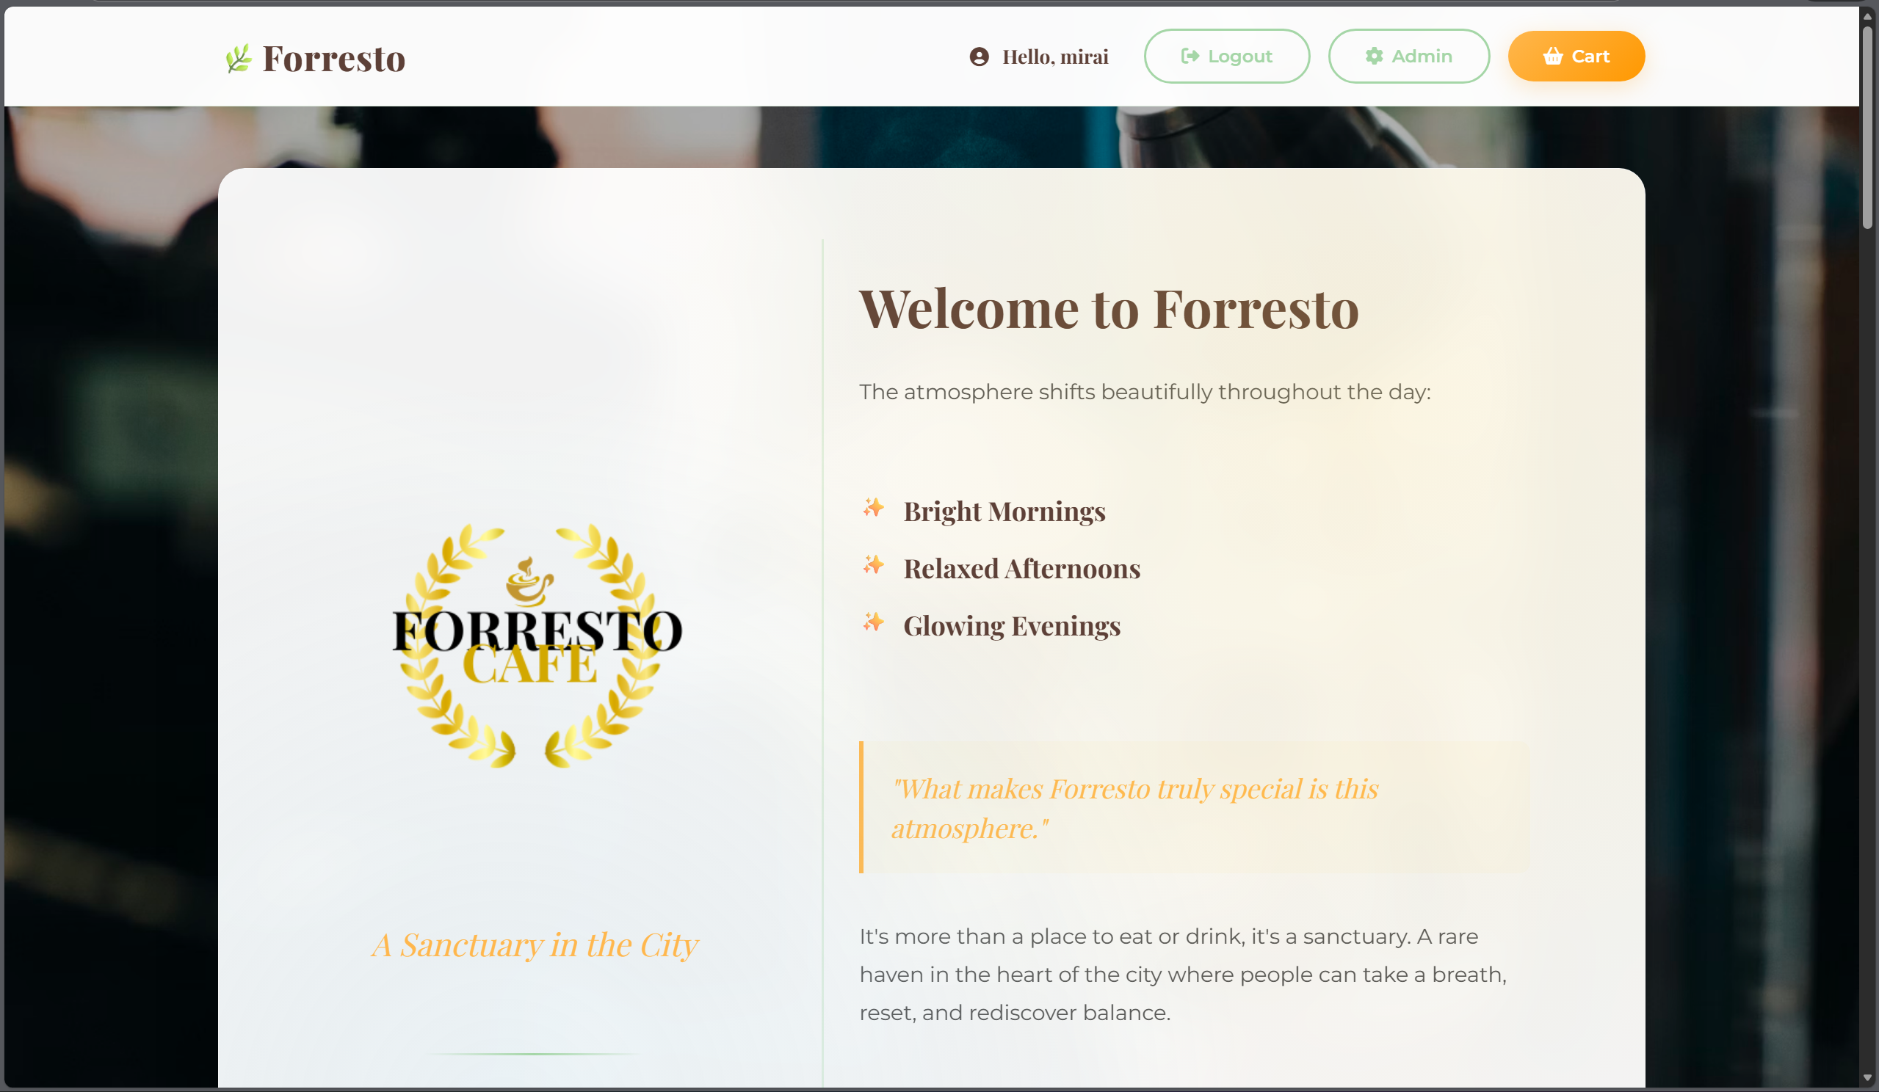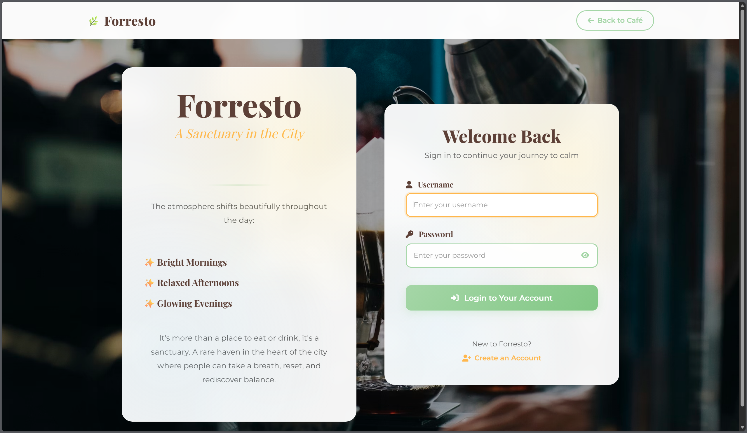

**4.3 User Flow Diagram**

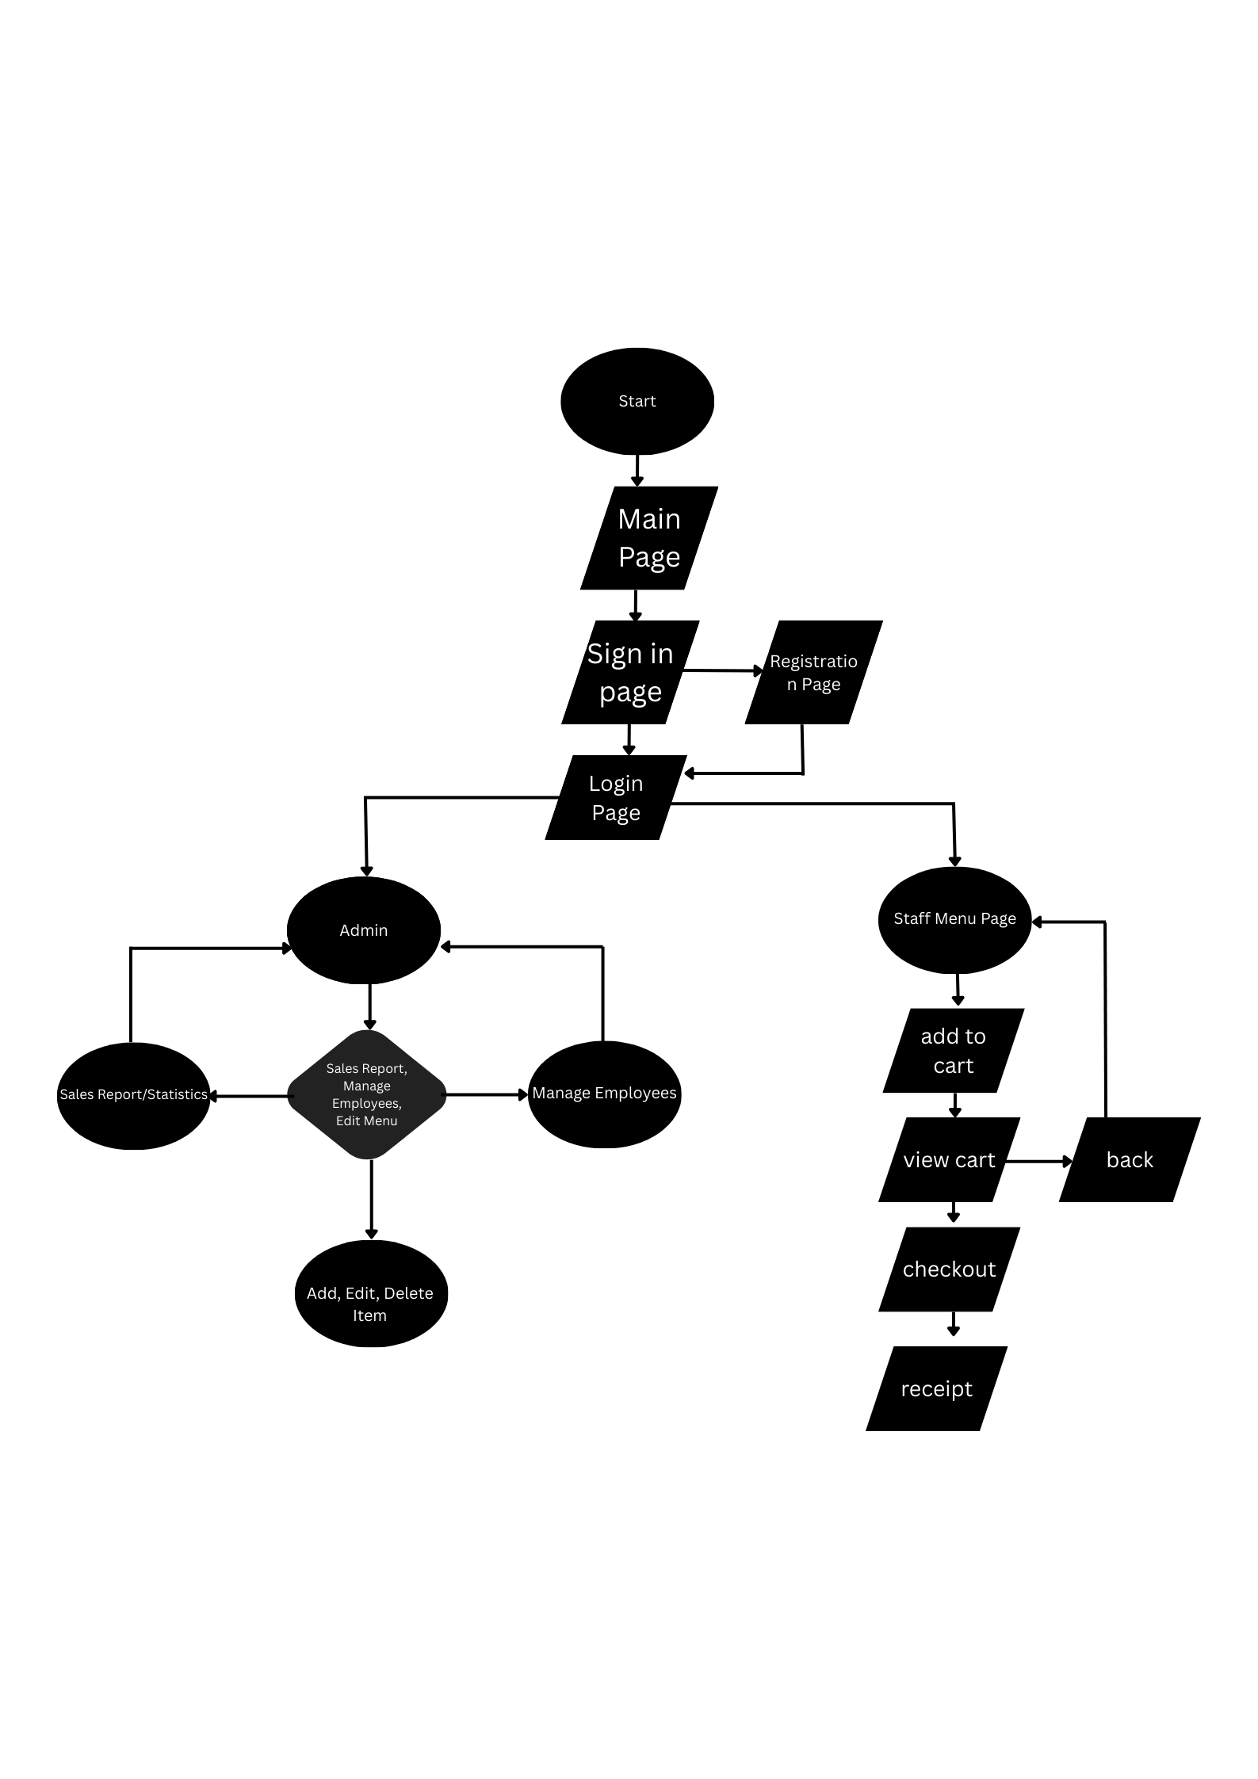

**5. Database Design**

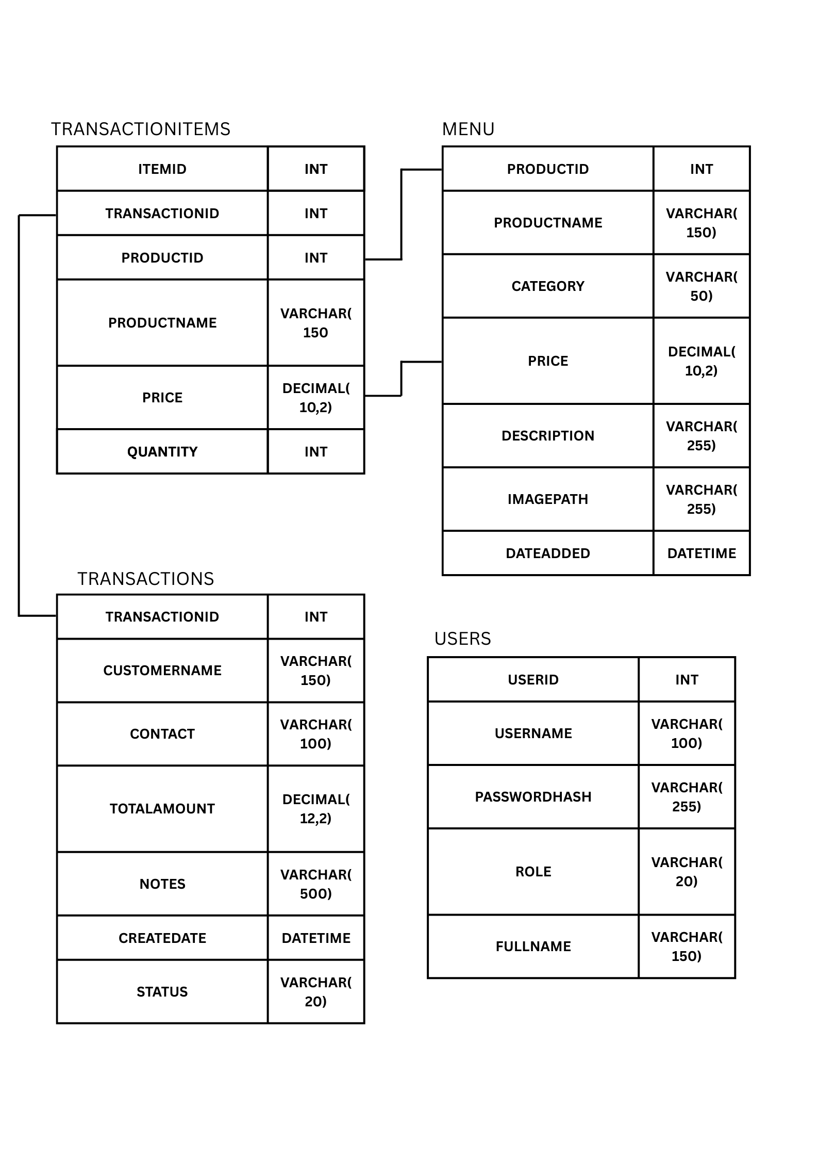

Order processing is handled through a relational database model where one transaction can contain multiple line items. The TRANSACTIONS table stores general order data (total cost, date, and status), while the TRANSACTIONITEMS table captures the specific details of each product purchased. By linking these via TRANSACTIONID, the system maintains a clean separation of data, prevents redundancy, and ensures that a snapshot of the product’s price is saved at the moment of purchase for accurate historical record-keeping.

**6. CODE DETAILS**This project utilizes a PHP-based backend to handle business logic and database communication, paired with a frontend built on HTML and CSS. JavaScript is integrated to provide a more responsive user experience through dynamic UI components.

**6.1 Folder Structure Explanation**

Uploads Folder – Contains all images used such as the logo and the items on the menu. Upon adding products to the menu, images are saved here automatically.  
**accounts.php** – Interface for viewing and managing all user accounts.

**add_product.php** – Tool for adding new items to the product menu.

**add_to_cart.php** – Background AJAX handler for seamless cart updates.

**admin_dashboard.php** – Central administrative hub for system-wide control.

**cart.php** – Interface for reviewing, managing, and updating cart contents.

**checkout.php** – Handles the final transaction and payment processing.

**delete_account.php** – Functionality to permanently remove user accounts.

**delete_product.php** – Functionality to remove items from the inventory.

**edit_account.php** – Interface for modifying existing user account details.

**edit_product.php** – Tool for updating product descriptions, prices, or info.

**index.php** – The main storefront featuring the product menu and shopping cart.

**login.php** – Secure user authentication and sign-in system.

**logout.php** – Terminates active sessions and logs users out securely.

**orders.php** – Dashboard for viewing and managing pending and past orders.

**productlist.php** – Master display of the current product catalog.

**receipt.php** – Generates order confirmations and post-purchase summaries.

**register.php** – System for onboarding and creating new user accounts.

**6.2 GITHUB REPOSITORY**

**GitHub Link:** [**rayyy12/refactored-fiesta**](https://github.com/rayyy12/refactored-fiesta) **Youtube Link: https://youtu.be/VkrBCyf0EzM**